Your digital image of your passport must be:
- In color
- In JPEG (.jpg or .jpeg) file format
- Equal to or less than 500 kB (kilobytes) in file size (less than 10 kB is not accepted)
- Only the first page. full-length images are not acceptable.
- In a rectangular aspect ratio ( height must be less than width )
- Be sized in 800(minimum-width) x 600(minimum-height) pixels
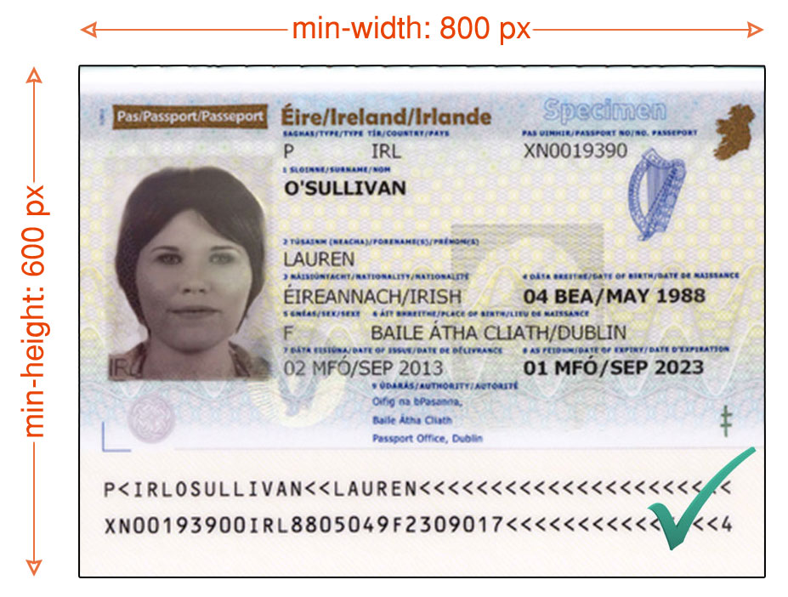
- Sharp without any visible pixels
- properly exposed (too dark or light is not acceptable)
- In a right position.
- Clear and all characters must be readable.

