Your passport photos must be:
- In color
- In JPEG (.jpg or .jpeg) file format
- Equal to or less than 500 kB (kilobytes) in file size (less than 10 kB is not accepted)
- In a rectangular aspect ratio (height must be greater than width)
- Be sized in 400(minimum-width) x 600(minimum-height) pixels, with about 70-80% part of the photo must be filled by the applicant’s face
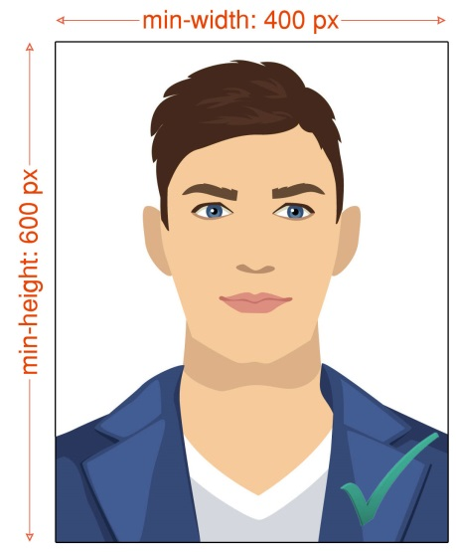
- Taken within the last 6 months to reflect your current appearance
- Taken in front of a plain white or off-white background
- Taken in full-face view directly facing the camera
- With a neutral facial expression and both eyes open
- Taken in clothing that you normally wear on a daily basis
- Uniforms should not be worn in your photo, except religious clothing that is worn daily.
- Do not wear a hat or head covering that obscures the hair or hairline, unless worn daily for a religious purpose. Your full face must be visible, and the head covering must not cast any shadows on your face.
- Headphones, wireless hands-free devices, or similar items are not acceptable in your photo.
- Eyeglasses are not allowed in visa photos, except in rare circumstances when eyeglasses cannot be removed for medical reasons; e.g., the applicant has recently had ocular surgery and the eyeglasses are necessary to protect the applicant's eyes. A medical statement signed by a medical professional/health practitioner must be provided in these cases. If the eyeglasses are accepted for medical reasons:
  - The frames of the eyeglasses must not cover the eye(s).
  - There must not be glare on eyeglasses that obscures the eye(s).
  - There must not be shadows or refraction from the eyeglasses that obscures the eye(s).
- Photos digitally scanned from driver’s licenses or other official documents are not acceptable. In addition, snapshots, magazine photos, low quality vending machine or mobile phone photos, and full-length photographs are not acceptable.

